Butterfly Tracking System (BTS)

Use Case Summary Document

Version No. 1.1

Project Document Revision History
Version Number | Date | Revision Author | Description of Revision
1.0 | 11/21/2015 | Issam Jassim | Initial Creation
1.1 | 11/22/2015 | Issam Jassim/Yue Dai | Made multiple changes/corrections, Added Use Case Diagram

Table of Contents
1. Introduction 4
2. Project/Application Actors 4
3. Use Case List 5
4. Use Case Diagram(s) 6
5. Use Case Summary 7
5.1 Retrieve Butterfly Reports (UC-1) 7
5.2 Session Management (UC-2) 7
5.3 Create Tagging/Sighting (UC-3) 8
5.4 Update Tagging/Sighting (UC-4) 9
5.5 Administration (UC-5) 9
5.6 Submit and View Feedback (UC-6) 10
6. Use Case Summary Review and Signoff 11

Introduction
The purpose of Butterfly Tracking System is to monitor migration patterns of butterflies around the globe in order to preserve their habitat and analyze their behavior. When butterflies are tagged, the time and location is entered into the database. The tagged butterflies can then be tracked by reporters who will record the time and location of each sighting and update the database accordingly. The database will maintain a full record for each tagged butterfly, which contains the tag number, date tagged, and all times and locations it was sighted thereafter. The system is to use the gathered information to generate various tabular and visual reports for its users. The final product must be intuitive and easy to use, so that people with little or no computer skills could easily use it.
The Butterfly Tracking System will be implemented using a web-based interface so that it can be accessed using any modern web browser on any platform, including mobile devices, without the need of any additional software. Another benefit of such implementation is multi-user access to the system. The following is a list of core system functions:
- Maintain and display a list of taggers/reporters
- Maintain a list of user credentials for security and data integrity (Session Management)
- Allow taggers/reporters to add butterfly tagging/sighting information into the database
- Display various reports by different criteria(by tag number, tagger, reporter, location, or date)
- Allow users to upload/download daily tracking data files based on butterfly tag (Batch file)
- Given a coordinate and a radius (in miles) give a visual of all butterfly sightings in the region
- Provide a user-friendly visualization of the routes of butterflies
- Implement an real-time and intuitive dashboard
- Accept, store and display user comments and feedback

Project/Application Actors
Actor Name | Description
Guest | Any user who visits the system (enters BTS web site)
Registered User | Users that have an active account in the BTS system. These users can report and update own butterfly taggings and sightings and manage their accounts.
Administrator | Users with highest level of privileges. They can manage all user accounts/sightings/taggings.

Use Case List

Use Case ID | Use Case Name | Use Case Description
UC-1 | Retrieve Butterfly Reports | Enable all users to download or view various butterfly tagging and sighting reports
UC-2 | Session Management | Manages user registration, login, and logout.
UC-3 | Create Tagging/Tagging | Enables all registered users to report butterfly taggings and sightings.
UC-4 | Update Tagging/Sighting | Enables all registered users to update or delete their own butterfly taggings and sightings.
UC-5 | Management | Enables administrators to update or delete all user accounts, taggings, and sightings.
UC-6 | Submit and View Feedback | Enables all users to view and submit personal feedback related to their experience using the BTS.

Use Case Diagram(s)
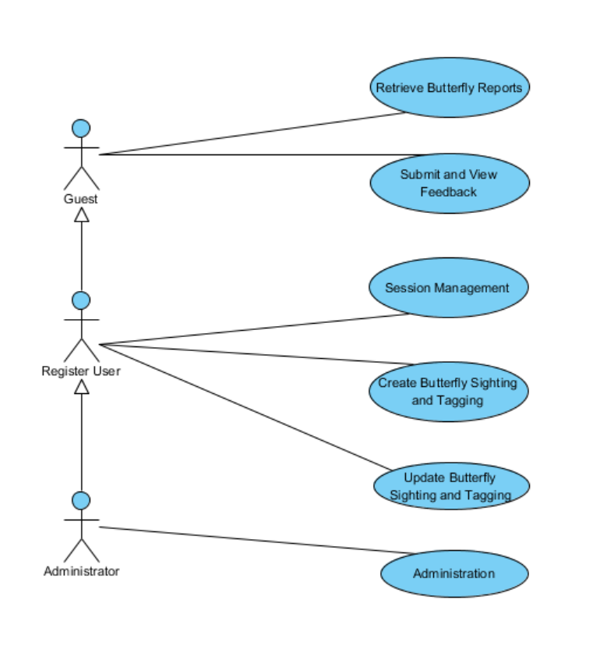

Use Case Summary

Retrieve Butterfly Reports (UC-1)
The purpose of this use case is to let the user retrieve information or view various reports/diagrams about butterfly tagging/sightings using different criteria from the system. The functionalities are categorized into either functional or non-functional requirement. The functional ones listed are as follows:
- Retrieve Butterfly Tracking Report: Display or allow the user to download various reports by different criteria(by tag number, tagger, reporter, location, or date)
- Custom Region Sightings: Given a coordinate and a radius (in miles) by the user, give a visual of all butterfly sightings in the region
- Butterfly Migration Route: Given a butterfly tag number by the user, display all the information about the butterfly, including the list of migration route in the format of visual table.

The system will use the same criteria to for displaying and batch file processing of butterfly reports. This criteria will include: Butterfly Tag ID, Date, Butterfly Sighter/Tagger, Location, State, Country, Latitude, and Longitude.
List of Actors:
Actor Name | Role | Description
Guest | Main | Any user who visit the website
Registered User | Main | Any user with an active account
Administrator | Main | Registered Users with Administrator status

Session Management (UC-2)
The purpose of Session Management is to control user access to the System as well as keep track of all changes made by different users. This use case will cover three distinct but closely related functionalities:
- User Registration: Enables visitors/guests to create an account to gain more privileges (become Registered Users).
- User Login: Enables registered users to login using their credentials (username/email and password), so they can report/update their own butterfly tagging/sightings and manage their account.
- User Logout: Enables users that area already logged in to log out to keep their accounts secure.
The users of the system will be divided into three categories. The categories from lowest level of privileges to highest are: Guests, Registered Users, and Administrators. A brief description of each user category is given below:
Guest: Any user that visits the website. This type of user will not require an account and will have limited access to the system. Guests will be able to view or download butterfly tracking information, but will not be able to make any changes to the database.
Registered User: A user that has an active account in the system is considered to be a registered user. This type of user can report and update own butterfly taggings and sightings, as well as make changes to his or her account information.
Administrator: This type of user has the highest level of access to the system. Therefore, in addition to all privileges enjoyed by registered users, this user will be able to update all taggings and sightings, as well as manage all user accounts, which includes granting them administrator status.
List of Actors:
Actor Name | Role | Description
Guest | Main | Any user who visit the BTS website
Registered User | Main | Any user who has an account in BTS
Administrator | Main | Registered users with Administrator status

Create Tagging/Sighting (UC-3)
This use case describes the process of entering butterfly tagging and sighting data that is collected by reporters to the system. Registered Users and Administrators have the ability to report tagging and sighting either by adding one new record at a time using the appropriate form or by uploading a batch file to add to process multiple records to the system. In both cases the system will verify the validity of the data before any records are inserted into the database. The system prompts the user with appropriate error messages when necessary to if invalid data is detected. This use case will cover three functionalities as follows:
- Create Tagging: For users to report butterfly taggings.
- Create Sighting: For users to report butterfly sightings.
- Upload Batch File: For users to upload a batch file that contains any number of butterfly taggings and/or sightings to be processed at once.

List of Actors for this use case:
Actor Name | Role | Description
Registered User | Main | Users that have an active account in the system
Administrator | Main | Registered users that have administrator status

Update Tagging/Sighting (UC-4)
The tracking or sighting data that collected by reporters should be added to previous information that been collected to maintain updated records of butterfly tracks. Registered users have the ability to update data by modify their own tagging record or sighting record inside the system. The system should have ability to validate entered data. The system prompts the user by prober messages depends on process steps. The functionalities are categorized into either functional or non-functional requirement. The functional ones listed are as follows:
- Registered user update his/her own tagging report
- Registered user update his/her own sighting report
- Registered user update his/her own account

List of Actors for this use case:
Actor Name | Role | Description
Registered user | Main | Any user who has an account in BTS and can access to the system
Administrator | Secondary | Registered Users that have full right access to manage the system

Administration (UC-5)
The purpose of this use case is to let the administrator manage the account of other users which include other administrators and taggers/sighters and manage all the records inside this system. The functionalities are categorized into either functional or non-functional requirement. The functional ones listed are as follows:
- Administrator create new account for other users(administrators and taggers/sighters)
- Administrator update existed account of other users(administrators and taggers/sighters)
- Administrator delete existed account of other users(administrators and taggers/sighters)
- Administrator update all the records inside the system(butterfly, sighting)
- Administrator delete records inside the system(butterfly, sighting)

List of Actors for this use case:
Actor Name | Role | Description
Administrator | Main | Users who manage the whole system

Submit and View Feedback (UC-6)
The purpose of collecting user feedback is to gather user experience and opinion about the Butterfly Tracking System. This information will help us analyze the performance and functionality of the system as, and get user feedback about the gathered butterfly tracking information.
Any user will be able to submit feedback and comments about his or her experience with the Butterfly Tracking System. Users will also be able to view all previously submitted feedback which enables this feature to be a means of user-interaction. Users are categorized into Guests, Registered Users, and Administrators, but they will all be able to use all functionalities outline in this document.
List of Actors for this use case:
Actor Name | Role | Description
Guest | Main | Any user who visit the website
Registered User | Main | Users that have an active account in the system
Administrator | Main | Registered users that have administrator status

Use Case Summary Review and Signoff
Review and Signoff of the Use Case Summary
Name | Project Team Role | Signature | Date
Issam Jassim | Team Leader | Ikj | 11/24/2015
Yue Dai | Front-end Developer | yd | 11/24/2015
Xiuyan Xin | Front-end Developer | xx | 11/24/2015
Nesrin Mohammed | Database Manager | nm | 11/24/2015

